

CLIENT: | Thelen Kia | PHONE #:
SPOT: | THEL-KI-T210201 Feb Thelen Kia | FAX # :
LENGTH: | :30 | SALES REP: | Larry H.
DATE: | 2/5/2021 | PRODUCER | A. Dennis

GRAPHICS | Video | AUDIO
Thelen Kia Logo  Euclid Ave. - Bay City  www.ThelenKia.com  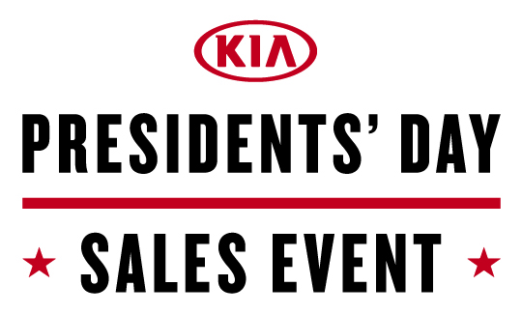  2021 Kia Forte LXS  Purchase From Just $225/mo  4.9% APR for 84 Months  $1,995 Down  Taxes, title & license fees extra. 4.9% APR for 84 months equals $14.09 per $1,000 financed through WAC, with approved credit, for well qualified buyers. Not all customers will qualify. No security deposit required. See Thelen Kia for details. Ends March 1, 2021.  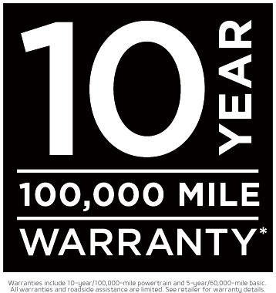  Warranties include 10-year/100,000-mile powertrain and 5-year/60,000-mile basic. All warranties and roadside assistance are limited. See retailer for warranty details.  2021 Kia Seltos LX AWD  Lease From Just $199/mo  For 36 Months $1,995 Due At Signing  Lease 10,000 miles per year for well qualified buyers with approved credit. Taxes extra. No security deposit required. See Thelen Kia for details. Ends January 31, 2021.  Think Thelen (Logo)  Kia (logo)  Euclid Ave. - Bay City www.ThelenKia.com | GFX: Kia Logo  GFX: 2021 Kia Forte LXS photo  GFX: Various 2021 Kia Models  GFX: 2021 Kia Seltos photo  GFX: Logo Animation  Video: Thelen Kia Dealership drone footage | Announcer: (:)  Save MORE at Thelen Kia in Bay City!  The deals are historic during the Kia Presidents’ Day Sales Event!  Right now buy a new Kia Forte LXS for just $225 a month! That’s right... purchase for just $225 a month!  Plus you’ll get Kia’s 10-year/100,000-mile limited warranty!  Or lease a new Kia Seltos LX for just $199 a month!  Thelen Kia gets you more for your money! Euclid avenue in Bay City! Online thelenkia.com  Thelen Kia - It’s the Right Thing to Do!

